Statistical Consulting Center
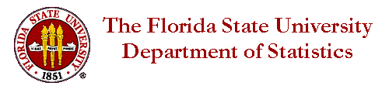
Liability Release Form

I (client) HEREBY ACKNOWLEDGE that I have voluntarily elected to contact the Statistical Consulting Center (consulting center) for assistance, and that the consulting centers involvement does NOT indicate in any way that I turned over any or all responsibility of my work or education to the consulting center or any individual associated with the consulting center. I acknowledge that I am responsible for maintaining appropriate confidentiality processes when dealing with such information, and collecting any necessary agreements/signatures from the consulting center when confidential information is shared.

FSU, Department of Statistics, and the Statistical Consulting Center assumes no responsibility for any incident, indirect or direct, resulting in damages of any kind due to the use or actions as a result of the work or shared information of the consulting center. This includes but is not limited to (1) reliance on the materials or products presented, (2) costs of replacement goods, (3) loss of use, data or profits, (4) delays or business/education interruptions, (5) and any theory of liability, arising out of or in connection with the use or performance of information) whether or not the consulting center has been advised of the possibility of such damages. Client agrees to hold the consulting center and any of their agents harmless for any such damages that may arise from the customer use of products or shared information, either purchased or offered “free of charge” to the client.

(Students)
In addition, I have read and I agree to follow all aspects of ethical behavior outlined in FSU’s Academic Honor Code and Student Conduct Code
Initial _________
Name _________________________________________________
Date ________________
Signature ______________________________________________

Consulting Center Representative ____________________________________

