Overview
The Statistical Consulting Center at Florida State University is a research assistance facility for the students, faculty, and staff at FSU. The Center is a function of the graduate program within the Department of Statistics at Florida State University. The Statistical Consulting Center is a free service for members of the FSU community. When requested, clients from outside the FSU community are given at least a one-hour consultation. The Statistical Consulting Center also holds walk-in hours to assist clients on a first-come first-serve basis. Currently, the Consulting Center is also expanding to serve as analysts for grants needing statistical support. Services included but are not limited to:
Translating research questions and hypotheses into statistical terms
Designing sampling procedures
Choosing appropriate statistical methods
Interpreting computer output
Phrasing statistical results
Referrals to other statistical help
The Statistical Consulting Center generally does not perform actual analyses.
Walk-in hours for the 2009-2010 academic year were held on Monday-Thursday afternoons in Strozier Library Consultation Room A. Appointments were planned to accommodate both the consultant’s and the clients’ specific scheduling needs. The majority of appointments were held at the end of the week.
Summary of Business Activities

Graduate students Jelani Wiltshire, Sutan Wu, Nicole Li, and Kelly McGinnity served as the consultants for the consulting center this year. During the fall 2009 semester, Jelani and Sutan were the primary consultants, while Nicole and Kelly took on observatory roles, observing the consulting sessions for the most part but later consulting with some clients on their own. During the spring 2010 semester, Jelani became the lead consultant after Sutan was offered a job and moved away. Nicole and Kelly were solo consultants, splitting the appointments with Jelani.

On average, consultants had 3-4 appointments each week, for a total of about 100 appointments over the course of the two semesters. The demand was relatively consistent across the months, with slight increases at the beginning and end of the semester, and close to important dates such as submission deadlines for research proposals or dissertations.

The task of holding walk-in hours was split up between the consultants. There was no appointment required. Clients were allowed to drop in whenever they wanted. The spring semester was busier than the fall, as more people became aware of our existence. We would also experience a spike in demand close to important dates such as submission deadlines for research proposals or dissertations, and midterm and final exams in classes.

Appointment Summary

PIE CHART

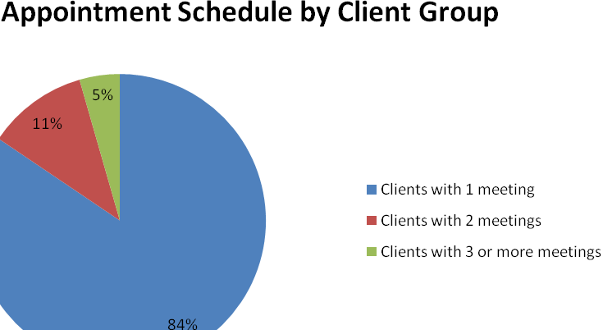
The majority of appointment clients this year were Doctoral students seeking assistance for the quantitative aspect of their dissertations. We also met with some Masters students writing their theses or working on a research project. On some few occasions, faculty members were provided statistical advice for their research work. Over time, we are proud to say that we have been able to provide statistical services for clients from various departments of the University community as indicated below:

Anthropology
Art Education
Biology
Chemistry
Communication Disorders
Dance
Engineering
Exercise Science
Educational Psychology and Learning Systems Department
Family and Children Sciences
Family and Consumer Sciences
Fashion Design
General Education
Instructional Systems
Mathematics Education
Meteorology
Music Therapy
Nursing
Nutrition
Oceanography
Physical Education
Physics
Psychology
Public Administration
Social Work
Sociology
Sports Management and Recreation Management
Textiles and Consumer Sciences

Initial consultations and follow-up appointments were scheduled throughout the clients’ research processes until the completion of the statistical research. The most frequent statistical ideas used were t-tests, ANOVA, basic linear regression, logistic regression, Chi-square, factor analysis, sample size calculations, and survey data analysis. The consulting center is currently able to advise clients as to the functions of computer packages such as SPSS, SAS, and Excel, but does not perform a client’s actual analysis.

Typical Cases

In fall of 2009, a Masters student from the meteorology department was looking for help with the data analysis portion of his thesis. He had a very large number of variables, so we first assisted him in using principal component analysis to reduce the dimension of his data. Once he had a final data set, he came back to the consulting center for help with logistic regression and cross-validation. We helped him split up his data set, run the regression analysis, and make a ROC curve of both the training and testing data set to evaluate his model, explaining the statistics behind the procedures along the way. We used SAS for the majority of the analysis.

In spring of 2010, a Doctoral student from the University of Florida College of Nursing, and employee at FSU’s Thagard Health Center, came to us for help with her doctoral final project. She had taken a Pre-Intervention and a Post-Intervention survey regarding the seasonal influenza vaccine, and needed assistance analyzing the results, and identifying factors that positively and negatively affected behavior to receive the vaccine. We suggested tests such as Chi-square and t-tests that would help her determine significant relationships. We also helped her handle missing data, format her Excel file so that she could properly import it into SPSS, and showed her how to perform the suggested tests.

When a client contacts the Consulting Center at the beginning of the research process, the consultant is able to assist in every aspect of the statistical design of the study. Consultants can advise clients on how to determine proper sampling strategies and sizes, the collection of data, initial demographic analysis and interpretation of data, and specific statistical procedures to answer the desired research questions or meet the client’s research goals. Clients at each stage of this research process frequently contact the Consulting Center and are assisted until the completion of the statistical aspects of their research.
Walk-in hours summary

PIE CHART
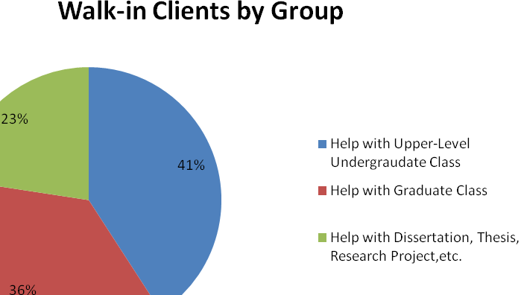
The majority of walk-in hours clients were looking for help in an upper-level undergraduate or graduate level statistics-related class at FSU. Many students were regular visitors to the consultation room and came to us for help with homework assignments and tests. Other clients were looking for assistance with their dissertations, theses, or research projects. Often this would involve advising them on running tests or interpreting output on computer programs such as SPSS. If the consultation room were extremely busy we would sometimes ask these clients to schedule an 1-on-1 appointment outside of walk-in hours so we could devote all of our attention to their research problem, rather than trying to jump back and forth to assist multiple clients in the room.

This year, we are proud to say that we have been able to provide statistical services for clients in various statistics-related courses as indicated below:

CCJ 5705 – Research Methods in Criminology I
EDF 5400 – Basic Descriptive and Inferential Statistics Applications
GEO 4185 – Spatial Data Analysis
LIN 5932 – Research Methods
MAR 3023 – Basic Marketing Concepts
PAD 5701 – Quantitative Analysis
PAD 6705 – Analytical Tech for Public Administration
POS 3713 – Political Science Research
STA 3024 – SAS Data and Stat Analysis
STA 4202/5602 – ANOVA and Design of Experiments
STA 4203 – Applied Regression Analysis
STA 4321 – Intro to Mathematical Statistics
Reflections
Once again, working in the Statistical Consulting Center has allowed us the opportunity to see the wide variety of fields where the discipline of statistics can be useful. From the perspective of a graduate student in Statistics, the Center is an opportunity to take what we have learned in the classroom and apply them to the real world problems. It has also been rewarding to know that in some small way we have been able to help so many different people in this collaborative research process.

We would like to thank Dr. Steve Ramsier for his continued organization, advice, and assistance with problematic cases throughout the school year.

